**Software Engineering Tools Lab**

Assignment No-2

(Module 2- Software Development Frameworks)

(Note: Solve below assignment in a group of 2 students, for question no 1 for every group 1 Framework/IDE/Software will be assigned, for question no 2 seperate dataset will be assigned to each group.)

**Name: Sonal Subodh Mane**

**Name: Muskan Raju Attar**

**PRN:2019BTECS00017**

**PRN:2019BTECS00009**

**Batch:T1**

**1. List of Frameworks/IDEs/Softwares**

**a. Eclipse**

**b. Android SDK**

**c. Node.Js**

**d. DotNet**

**e. Ruby on Rails**

**f. Anaconda**

**g. Google colab**

**For every Frameworks/IDEs/Softwares given above provide the answers for below questions**

**1. Original author**

**2. Developers**

**3. Initial release**

**4. Stable release**

**5. Preview release**

**6. Repository (with cloud support )**

**7. Written in (Languages)**

**8. Operating System support**

**9. Platform ,portability**

**10. Available in (Total languages)**

**11. List of languages supported**

**12. Type (Programming tool, integrated development environment etc.)**

**13. Website**

**14. Features**

**15. Size (in MB, GB etc.)**

**16. Privacy and Security**

**17. Type of software (Open source/License)**

**18. If License- Provide details.**

**19. Latest version**

**20. Cloud support (Yes/No)**

**21. Applicability**

**22. Drawbacks (if any)**

**Answers:**

**Ruby On Rails:**

Ruby on Rails, or Rails, is a server-side web application framework written in Ruby under the MIT License. Rails is a model–view–controller (MVC) framework, providing default structures for a database, a web service, and web pages. It encourages and facilitates the use of web standards such as JSON or XML for data transfer and HTML, CSS and JavaScript for user interfacing.

1. **Original author**

The original author of Ruby on Rails is David Heinemeier Hansson

1. **Developers**

David Heinemeier Hansson extracted Ruby on Rails from his work on the project management tool Basecamp at the web application company also called Basecamp (37Signals at the time). Hansson first released Rails as open source in July 2004, but did not share commit rights to the project until February 2005. In August 2006, the framework reached a milestone when Apple announced that it would ship Ruby on Rails with Mac OS X v10.5 "Leopard", which was released in October 2007.

1. **Initial release**

August 2004 , 17 years ago

1. **Stable release**

7.0.1 / 6 January 2022; 37 days ago

**5. Preview release**

Preview release of Rails 6.1 was released on December 9, 2020

1. **Repository (with cloud support )**

https://github.com/rails/rails

1. **Written in (Languages)**

Ruby

1. **Operating System support**

Ruby works quite well on any unix-like OS, that includes, besides Linux, macOS and any BSD.Ruby on Rails on Windows is not just possible, it's fabulous using WSL2 and VS Code.

1. **Platform ,portability**

It is generally considered to be a server-side web application development platform.

**10. Available in (Total languages):**3

**11. List of languages supported**

Rails combines the Ruby programming language with HTML, CSS, and JavaScript to create a web application that runs on a web server. Because it runs on a web server, Rails is considered a server-side, or “back end,” web application development platform (the web browser is the “front end”)

**12. Type (Programming tool, integrated development environment etc.)**

Ruby on Rails, or Rails, is a server-side web application framework written in Ruby.

**13. Website**

https://rubyonrails.org/

**14. Features**

seamless database table creations, migrations, and scaffolding of views to enable rapid application development

**15. Size (in MB, GB etc.)**

57.8 MB

**16. Privacy and Security**

In March 2012, security researcher Egor Homakov discovered a mass assignment vulnerability that allowed certain Rails applications to be remotely exploited, and demonstrated it by non-maliciously hacking GitHub after his earlier attempts at responsible disclosure were dismissed.

On September 24, 2013, a session cookie persistence security flaw was reported in Ruby on Rails. In a default configuration, the entire session hash is stored within a session cookie known as CookieStore, allowing any authenticated session possessing the session cookie to log in as the target user at any time in the future. As a workaround, administrators are advised to configure cookies to be stored on the server using mechanisms such as ActiveRecordStore.

Researchers Daniel Jackson and Joseph Near developed a data debugger they called "Space" that can analyze the data access of a Rails program and determine if the program properly adheres to rules regarding access restrictions. On April 15, 2016, Near reported that an analysis of 50 popular Web applications using Space uncovered 23 previously unknown security flaws.

**17. Type of software (Open source/License)**

MIT License

**18. If License- Provide details.**

The MIT License is a permissive free software license originating at the Massachusetts Institute of Technology (MIT) in the late 1980s.As a permissive license, it puts only very limited restriction on reuse and has, therefore, high license compatibility.

**19. Latest version**

Rails 7.0 was released on December 15, 2021.

**20. Cloud support (Yes/No):Yes**

It's easy to get started developing Ruby on Rails apps that run on Google Cloud.

**21. Applicability:**

Rails is a web application development framework written in the Ruby programming language. It is designed to make programming web applications easier by making assumptions about what every developer needs to get started. It allows you to write less code while accomplishing more than many other languages and frameworks.

**22. Drawbacks (if any)**

1. Runtime Speed and Performance.

2. Lack of Flexibility.

3. High cost of wrong decisions in development

**2.Implement linear regression problem using Google colab (Perform preprocessing, training and testing)**

**Dataset 1 -https://www.kaggle.com/spittman1248/cdc-data-nutrition-physical-activity-obesity**

**Dataset 2-** [**https://archive.ics.uci.edu/ml/datasets/Air+Quality**](https://archive.ics.uci.edu/ml/datasets/Air+Quality)

**Dataset 3-** [**https://archive.ics.uci.edu/ml/datasets/Appliances+energy+prediction**](https://archive.ics.uci.edu/ml/datasets/Appliances+energy+prediction)

**Dataset 4-** [**https://archive.ics.uci.edu/ml/datasets/Bike+Sharing+Dataset**](https://archive.ics.uci.edu/ml/datasets/Bike+Sharing+Dataset)

**Dataset 5-** [**https://archive.ics.uci.edu/ml/datasets/Demand+Forecasting+for+a+store**](https://archive.ics.uci.edu/ml/datasets/Demand+Forecasting+for+a+store)

**Dataset 6-** [**https://archive.ics.uci.edu/ml/datasets/Hungarian+Chickenpox+Cases**](https://archive.ics.uci.edu/ml/datasets/Hungarian+Chickenpox+Cases)

**Dataset 7-** [**https://archive.ics.uci.edu/ml/datasets/KDD+Cup+1998+Data**](https://archive.ics.uci.edu/ml/datasets/KDD+Cup+1998+Data)

**Dataset 8-** [**https://archive.ics.uci.edu/ml/datasets/Water+Quality+Prediction**](https://archive.ics.uci.edu/ml/datasets/Water+Quality+Prediction)

**For Dataset 3:**

**Linear Regression Using Google Colab:**

* **Preprocessing:**

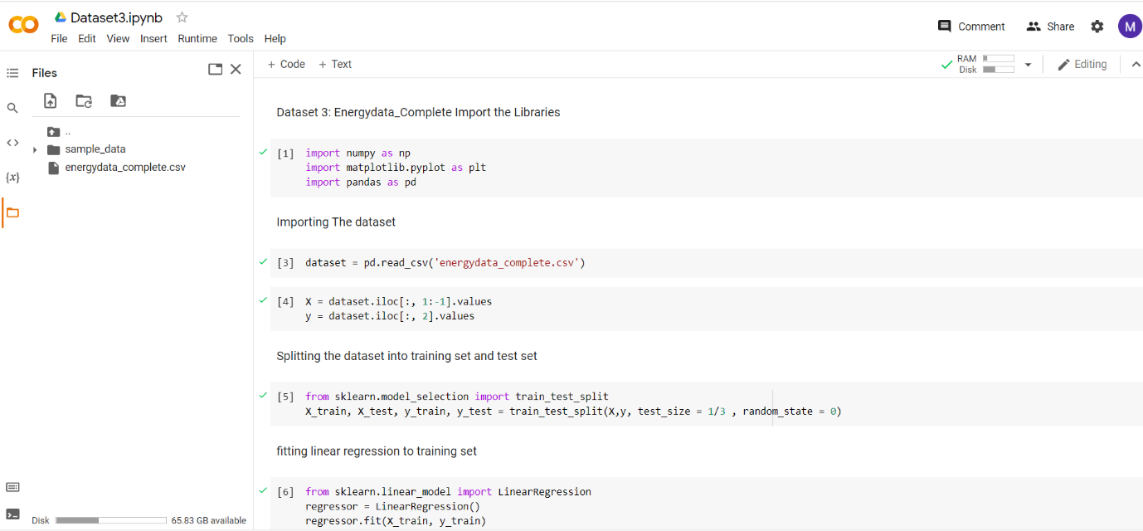

**training and Testing**

